**DUYTAN UNIVERSITY**

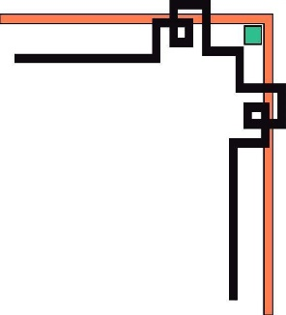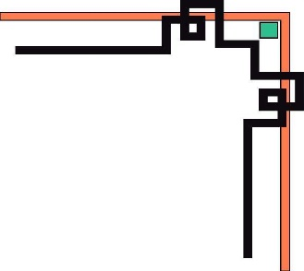

**INTERNATIONAL SCHOOL**

**--------------🙖🙐✰🙖🙐-------------**



**CMU-SE 100**

**INTRODUCTION TO SOFTWARE ENGINEERING**

**SYNTHESIS REPORT GROUP PROJECT**



**Mentor: Msc. Huy Nguyen Dang Quang**

***Team Member*:**

**Tuan, Nguyen Dinh(Leader)**

**Quyen, Le Huu**

**Phi, Nguyen Dinh**

**Huy,Than Quang**

**Trong,Tran Nguyen Huu**

**Group Project - Mentor:**

Name: Signature: Date:

Da nang, 12/2023

**PROJECT INFORMATION**

|  |  |
| --- | --- |
| **Project Acronym** | NNC |
| **Project Title** | Cafe Management System | | | |
| **Start Date** | 12/3 | **End Date** | 12/25 | |
| **Lead Institution** | International School, Duy Tan University | | | |
| **Team Member** | **Name** | **Email** | | **Phone** |
| 28211280315 | Nguyễn Đình Tuấn | nguyendinhtuancf2@gmail.com | | 0379676303 |
| 29211155174 | Lê Hữu Quyền | [lehuuquyen18092004@gmail.com](mailto:lehuuquyen18092004@gmail.com) | | 0905353824 |
| 29211355447 | Nguyễn Đình Phi | phinguyen18112005@gmail.com | | 0359575089 |
| 29211157231 | Thân Quang Huy | thanquanghuy2904@gmail.com | | 0387817183 |
| 29212254913 | Trần Nguyễn Hữu Trọng | trongtran34h@gmail.com | | 0395125027 |

**DOCUMENT NAME**

|  |  |  |  |
| --- | --- | --- | --- |
| **Document Title** | **Synthesis Report Group Project Document** | | |
| **Reporting Period** | 25 – Dec – 2023 | | |
| **Author(s)** | Tuấn,Quyền,Phi,Huy,Trọng | | |
| **Role** | Leader,Teammember,Teammember,Teammember,Teammember | | |
| **Date** | 12/3/23 | **Filename** | Team3_ CMU-SE-100_NNC |

**SIGNATURE**

***Document Approvals:*** *The following signatures are required for approval of this document.*

|  |  |  |  |
| --- | --- | --- | --- |
| **Mentor** | Huy, Nguyen Dang Quang | **Signature:** |  |
| **Date:** |  |
| **Team Lead** | Tuan,Nguyen Dinh | **Signature:** | Tuan Nguyen |
| **Date:** | 12/20/23 |
| **Team member(s)** | Quyen,Le Huu | **Signature:** |  |
| **Date:** |  |
| Phi,Nguyen Dinh | **Signature:** |  |
| **Date:** |  |
| Huy,Than Quang | **Signature:** |  |
| **Date:** |  |
| Trong,Tran Nguyen Huu | **Signature:** |  |
| **Date:** |  |
|  | **Signature:** |  |
| **Date:** |  |

**REVISION HISTORY**

|  |  |  |
| --- | --- | --- |
| **Version** | **Date** | **Description** |
| **1.0** | 12/5/2023 | **Make document for project** |
| **1.1** | 12/8/2023 | **UI changes and updates** |
| **1.2** | 12/13/23 | **Change and update new cafe genres** |
| **1.3** | 12/15/23 | **Upgrade search data on cafe genres** |
| **1.3.1** | 12/17/23 | **Update the cafe customers want** |
| **1.4** | 12/22/23 | **Fix the errors on the website that customers report** |

**TABLE OF CONTENTS**

**1. INTRODUCTION** 5

**2. DESCRIBE BUSINESS PROCESSES OF RESTAURANT** 5

**3. LIST OF PARTICIPANTS TO REQUIREMENTS GATHERING** 5

**4. THE TECHNICALS USING TO REQUIREMENTS GATHERING** 6

**5. ASSIGNMENT TEAM MEMBER TO REQUIREMENTS GATHERING** 6

**6. INTRODUCTION PROJECT** 6

**6.1. Project Objectives** 6

**6.2. Project Scope** 7

**6.3 Identify the Functional Requirement & Non-Functional Requirement** 8

**a) High level Functional Requirement (FR)** 8

**b) List of Non-Functional Requirement** 9

**7. THE USER REQUIREMENT ANALYSIS** 11

**7.1 Business Function Diagram** 11

**7.2 Context Model** 12

**a) Context Model** 12

**b) System Context Description** 12

**7.3 List of Actor** 12

**7.4. List of Use Cases** 13

**8. PROJECT PLAN** 13

**9. TECHNICAL CONSTRAINTS** 14

**9.1 Technical to develop:** 14

**9.2 Environment:** 14

**9.3 Another:** 14

**10. ANALYSIS & MODELING REQUIREMENT** 15

**10.1. Use Case Diagram** 15

**10.2. List of Business Rule** 15

**10.3. Activity Diagram** 16

**a) The steps performed of function abc….** 16

**b) Activity Diagram of function abc….** 17

**11. INTERFACE DESIGN** 19

**11.1. Introduction tool design** 19

**11.2 User Interface Design for ABC Function** 19

**12. CONFIGURATION MANAGEMENT** 20

**a) Introduction the tool Source Code Management** 20

**b) Introduction Key Functional** 20

**c) The Screen Shot apply Source Code Management of team** 20

**13. TESTING** 20

**a) Introduction to method testing apply of this project** 20

**b) Test Cases** 20

**14. CONTRIBUTION** 20

# **1. INTRODUCTION**

***Phúc Long*** *là một trong những thương hiệu nổi tiếng với nhiều loại thức uống được pha chế thơm ngon, chất lượng. Phục vụ chuyên nghiệp. Mức giá phải chăng.*

*Trụ sở chính: Công ty Cổ Phần Phúc Long Heritage - ĐKKD: 0316 871719*

*do sở KHĐT TPHCM cấp lần đầu ngày 21/05/2021*

*Nhà máy: D_8D_CN Đường XE 1, Khu Công Nghiệp Mỹ Phước III, phường Mỹ Phước, thị xã Bến Cát, tỉnh Bình Dương, Việt Nam*

*Địa chỉ: 61 Đ Nguyễn Văn Linh, Bình Hiên, Hải Châu, Đà Nẵng 550000*

*Điện thoại: 1900 234 518 (Ext.9100/ 9102)*

*Fax: (028) 6263 0379*

*Email: sales@phuclong.masangroup.com*

*info2@phuclong.masangroup.com*

# **2. DESCRIBE BUSINESS PROCESSES OF RESTAURANT**

***<*** *Tìm hiểu và mô tả các quy trình nghiệp vụ chính trong hoạt động của Nhà Hàng****>***

# **3. LIST OF PARTICIPANTS TO REQUIREMENTS GATHERING**

***<*** *Xác định các đối tượng liên quan để thu thập yêu cầu****>***

***Phỏng vấn ai:Chủ nhà hàng,Quan Ly quán,Phục vụ bàn,Thu Ngân ,Pha Chế***

# **4. THE TECHNICALS USING TO REQUIREMENTS GATHERING**

*< Xác định các phương pháp/Kỹ thuật để thu thập yêu cầu (quan sát, phỏng vấn, bảng hỏi, trao đổi trực tiếp dựa trên mô hình hoặc website có tính năng tương tự, tại sao sử dụng kỹ thuật này …)*

*Interview…..,dericosion(quan sát trực tiếp)*

# **5. ASSIGNMENT TEAM MEMBER TO REQUIREMENTS GATHERING**

*<Phân công một số thành viên nhóm đóng vai các đối tượng thu thập yêu cầu như đã xác định và tiến hành thu thập yêu cầu chức năng và yêu cầu phi chức năng (phải lập bảng phân công cụ thể từng người một làm gì, hỏi gì,…)>*

***Phân công***

*Danh sách mỗi người hỏi và* ***câu hỏi*** *hỏi từng người :* ***Phỏng vấn ai:Chủ nhà hàng,Phục vụ bàn,Thu Ngân ,Pha Chế***

# **6. INTRODUCTION PROJECT**

## **6.1. Project Objectives**

Allow customers to place orders and make payments directly from tablets at their tables, reducing the need for as many serving staff. The ordering system will display the menu items available that day with prices. Customers can select items and quantities on the touch screen interface.

Give the drinks preparation staff an interface to view incoming drink orders and mark when they are ready for pickup.

Provide the cashier with the ability to accept payments, calculate and print receipts. Sales reports can also be generated showing total daily revenue and items ordered.Allow customers to accumulate loyalty/reward points by scanning membership cards.

Implement the customer-facing ordering system on touch devices like iPads, while the drink preparation, point of sale, and management interfaces will run on Windows/Web platforms.

Design an easy to use system for all types of users - customers, baristas, cashiers, and managers.

In summary, the key goals are: **Automate much of the ordering and payment process to reduce labor costs, provide better visibility into orders and sales, implement loyalty programs, and ensure the system is intuitive for both staff and customers.**

## **6.2. Project Scope**

**The project scope**: for the cafe management system includes the development of 4 main modules: Order Placement, Beverage Preparation, Cashier, and Web Browsing. Each module serves specific functionalities and contributes to the overall goal of streamlining cafe operations. The key features and components within each module are as follows:

**1. Order Placement Module:**

Functionality:

- Display a menu of available drinks and their prices at the specific branch for the day.

- Allow customers to select drinks and specify quantities via a touchscreen interface.

- Provide a notification on the screen when the ordered drinks are ready for pickup at the service counter.

- Allow customers to view their current bill, including ordered and prepared drinks, total amount, and loyalty points.

- Support payment at the cashier counter and enable customers to scan loyalty cards for point accumulation.

**2. Beverage Preparation Module:**

Functionality:

- Allow daily updates to the list of drinks that can be served.

- Display information about ordered drinks and the quantity to be prepared.

- Enable confirmation from the beverage preparation staff when the drinks are ready.

**3. Cashier Module:**

- Functionality:

- Receive input from customers, such as table number and amount paid.

- Calculate and inform the customer of the amount to be returned (if any).

- Generate an end-of-day report for the cashier, including total daily revenue and a list of drinks ordered.

**4. Web Browsing Module:**

Functionality:

- Allow users to access the cafe's website to view the list of drinks available for the day at different branches.

**\*Non-Functional Requirements:**

User Interface:

- The customer-facing module must run on touchscreen devices (iPhone, iPad, Android) placed at dining tables.

- The beverage preparation and cashier modules must run on the WinForm/WebForm platforms.

-Usability:

- Ensure the system is user-friendly and easy to navigate for both customers and staff members.

The scope includes the development and implementation of these modules, with a focus on enhancing the overall efficiency of cafe operations, optimizing staff resources, and providing a seamless experience for both customers and cafe staff. The system aims to improve order accuracy, streamline payment processes, and provide real-time information for better decision-making.

# **6.3 Identify the Functional Requirement & Non-Functional Requirement**

### **a)** **High level Functional Requirement (FR)**

|  |  |  |
| --- | --- | --- |
| FR1 | Title | Display Menu |
| Stakeholder | User use tablets and phones placed at the table to order drinks |
| Description | Display menu of available drinks and prices for the day  Allow customers to select drinks and quantities on touch screen  Display menu items, prices. Allow ordering drinks, quantities on touch screens. |
| FR1.1 | Title | Order Placement |
| Stakeholder | User select drinks on tablets or phones |
| Description | Send customers to select drinks and specify quantities through a touchscreen interface.  Provide an option for customers to view and confirm their current order.  Send customer orders to mixologist. |
| FR1.2 | Title | Order Notification |
| Stakeholder | User waits for a drink |
| Description | Notify customers when order is ready for pickup through the touchscreen to pick up the order at the service counter. |
| FR1.3 | Title | View Current Bill |
| Stakeholder | User receives bill |
| Description | Allows customers to view current order status and bill for drinks ordered and loyalty points (if applicable). |
| FR1.4 | Title | Payment and Loyalty |
| Stakeholer | User payment for drinks use scan or cash |
| Description | Facilitate the payment process at the cashier counter. Allow customers to cash or scan and use loyalty cards at the table to accumulate points.(Register if you don't have) |
| FR2 | Title | Mixologist Processing |
| Stakeholer | Mixologist announces request to receive drinks |
| Description | Enable staff to update the list of drinks that can be served,  Display information about the ordered drinks and the quantity to be prepared when a customer places an order.  Allow the staff to confirm on the system once the beverage preparation is complete. |
| FR3 | Title | Order Payment |
| Stakeholer | Cashier collects and pays user money |
| Description | Receive input from the customer, such as table number and amount paid.  Calculate and inform the customer of the amount to be returned (if any). |
| FR3.1 | Title | Daily Summary |
| Stakeholer | The cashier a report at the end of the session |
| Description | Generate an end-of-day report for the cashier, including the total revenue for the day and a list of drinks ordered. |
| FR4 | Title | Menu information on the website |
| Stakeholer | User watching drinks on the web |
| Description | Allow users to access the cafe's website to view the list of drinks available for the day at different branches. |

### **b) List of Non-Functional Requirement**

**Usability:**

The system should be user-friendly and easy to navigate for both customers and staff members.

The touchscreen interface for customers should be intuitive and responsive.

The web interface for staff members should be designed for easy navigation and efficient workflow.

**Reliability:**

The system should have a high level of reliability to ensure smooth operations during business hours.

The downtime of the system should be minimized to avoid disruptions to the cafe's operations.

**Performance:**

The system should respond to user inputs promptly, especially in the customer-facing.

The web interface for staff should handle concurrent users efficiently, ensuring a smooth workflow for employees.

**Scalability:**

The system should be scalable to accommodate an increasing number of users, especially during peak hours.

It should support the addition of new branches or expansion without a significant decrease in performance.

**Security:**

Customer data, including payment information, should be stored securely and comply with relevant data protection regulations.

Access to sensitive information in the staff should be role-based, ensuring that only authorized personnel can access specific functionalities.

**Compatibility**:

The customer-facing should be compatible with popular mobile devices such as iPhones, iPads, and Android devices.

The staff-facing should be compatible with both WinForm and WebForm platforms.

**Maintainability:**

The system should be designed in a way that allows for easy updates, maintenance, and modifications.

Code should be well-documented to facilitate future enhancements or changes.

**Integration:**

The system should be able to integrate with external systems such as payment gateways for seamless transactions.

Integration with inventory management systems may be necessary to keep track of available ingredients for drinks.

**Auditability:**

The system should log relevant activities for auditing purposes, including user actions, transactions, and system changes.

**Accessibility:**

The customer-facing on touchscreen devices should adhere to accessibility standards to ensure that all customers, including those with disabilities, can use the system effectively.

# **7. THE USER REQUIREMENT ANALYSIS**

## **7.1 Business Function Diagram**

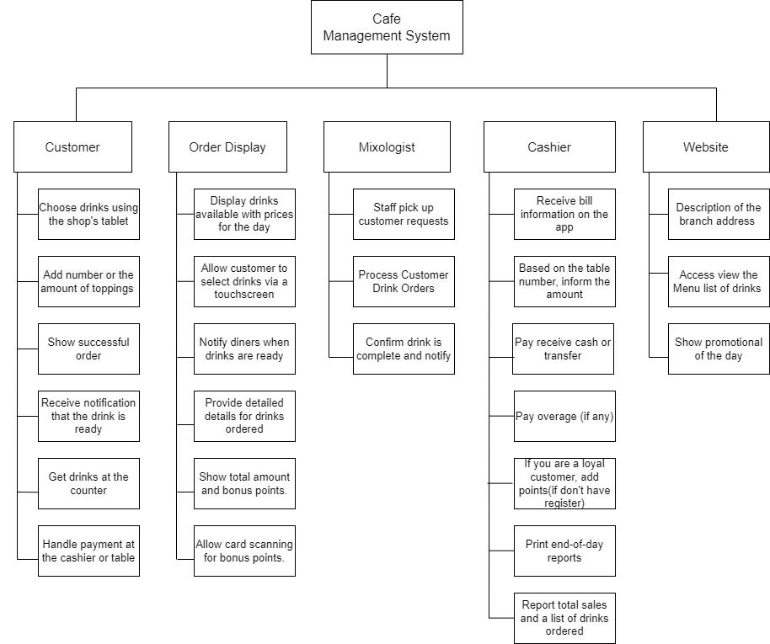

## **7.2 Context Model**

### **a) Context Model**

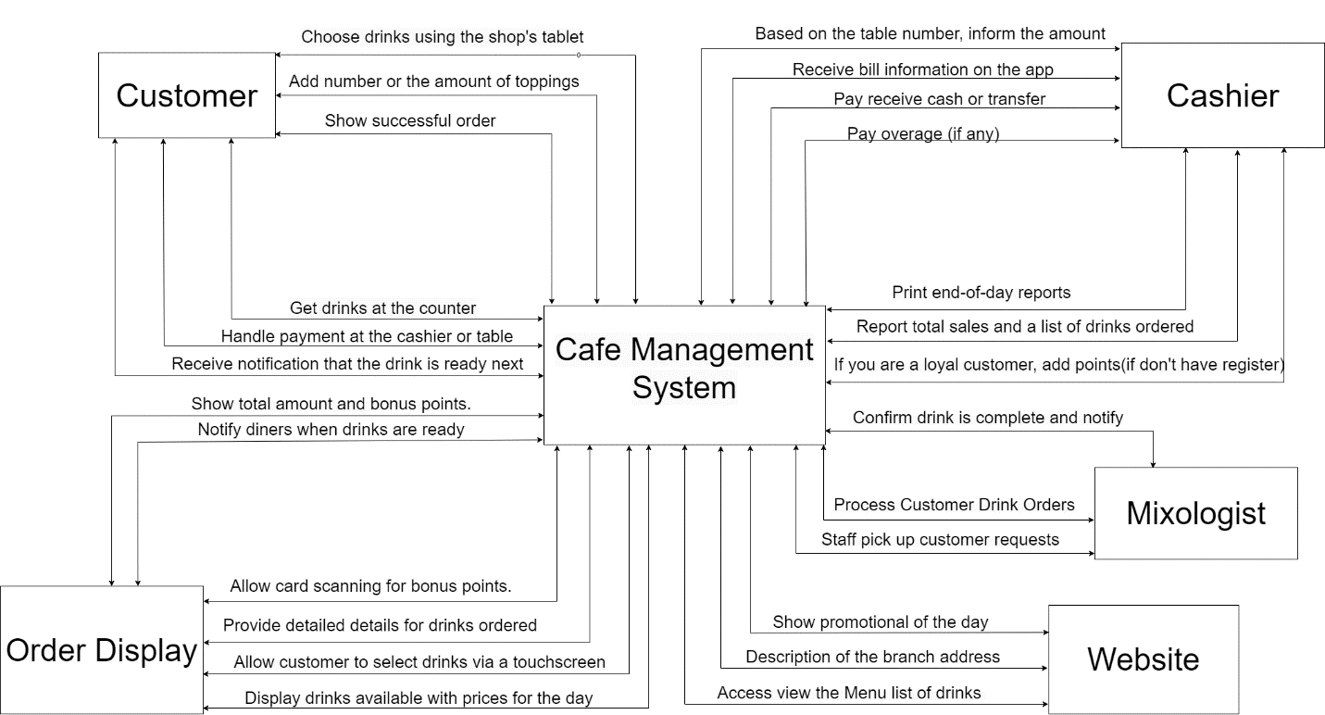

### **b) System Context Description**

## **7.3 List of Actor**

|  |
| --- |
| **Customer:**  Interacts with the "Order Placement " to select and order drinks through a touchscreen.  Views the current bill, including ordered drinks, prepared drinks, total amount, and loyalty points.  Goes to the cashier to make payments scan or cash and may use a card to accumulate loyalty points. |
| **Mixologist:**  Receives drink orders from customers.  Views information on the screen regarding the drinks to be prepared and the quantity.  Confirms the completion of drink preparation on the system. |
| **Cashier :**  Receives information from the customer, including the table number and amount paid.  Calculates and returns change (if necessary).  Prints end-of-day reports, including total daily revenue and a list of drinks ordered. |
| **Web Browser User:**  Accesses the cafe's website to get information about the drinks served in the day at different branches. |

## **7.4. List of Use Cases**

|  |  |  |
| --- | --- | --- |
| Use case ID | Use case name | Functional Req. |
| *UC.01* | Display Menu | *FR1.1* |
| *UC.02* | Order Placement | *FR1.2* |
| *UC.03* | Order Notification | *FR1.3* |
| *UC.04* | View Current Bill | *FR1.4* |
| *UC.05* | Payment and Loyalty | *FR1.5* |
| *UC.06* | Mixologist Processing | *FR2* |
| *UC.07* | Order Payment | *FR3* |
| *UC.08* | Daily Summary | *FR3.1* |
| *UC.09* | Menu information on the website | *FR4* |

# **8. PROJECT PLAN**

# **9.** **TECHNICAL CONSTRAINTS**

## **9.1 Technical to develop:**

* ***Languages****: Python, Nodejs,C++, Java,Html*
* ***Server:*** *Socket.io*

## **9.2 Environment:**

* ***Web browsers****: Google Chrome, Molliza Firefox, Apple Safari, Cốc Cốc, Microsoft Edge.*
* ***Environment:*** *Microsoft windows, Mac Os, Android, iOS,..*

## **9.3 Another:**

* ***Management tool****: Google Drive, Slack*
* ***Design tool****: Figma*
* ***Manage Source code tool****: Git,Github*
* ***Test tool*** *: Katalon Studio*

# **10. ANALYSIS & MODELING REQUIREMENT**

## **10.1. Use Case Diagram**

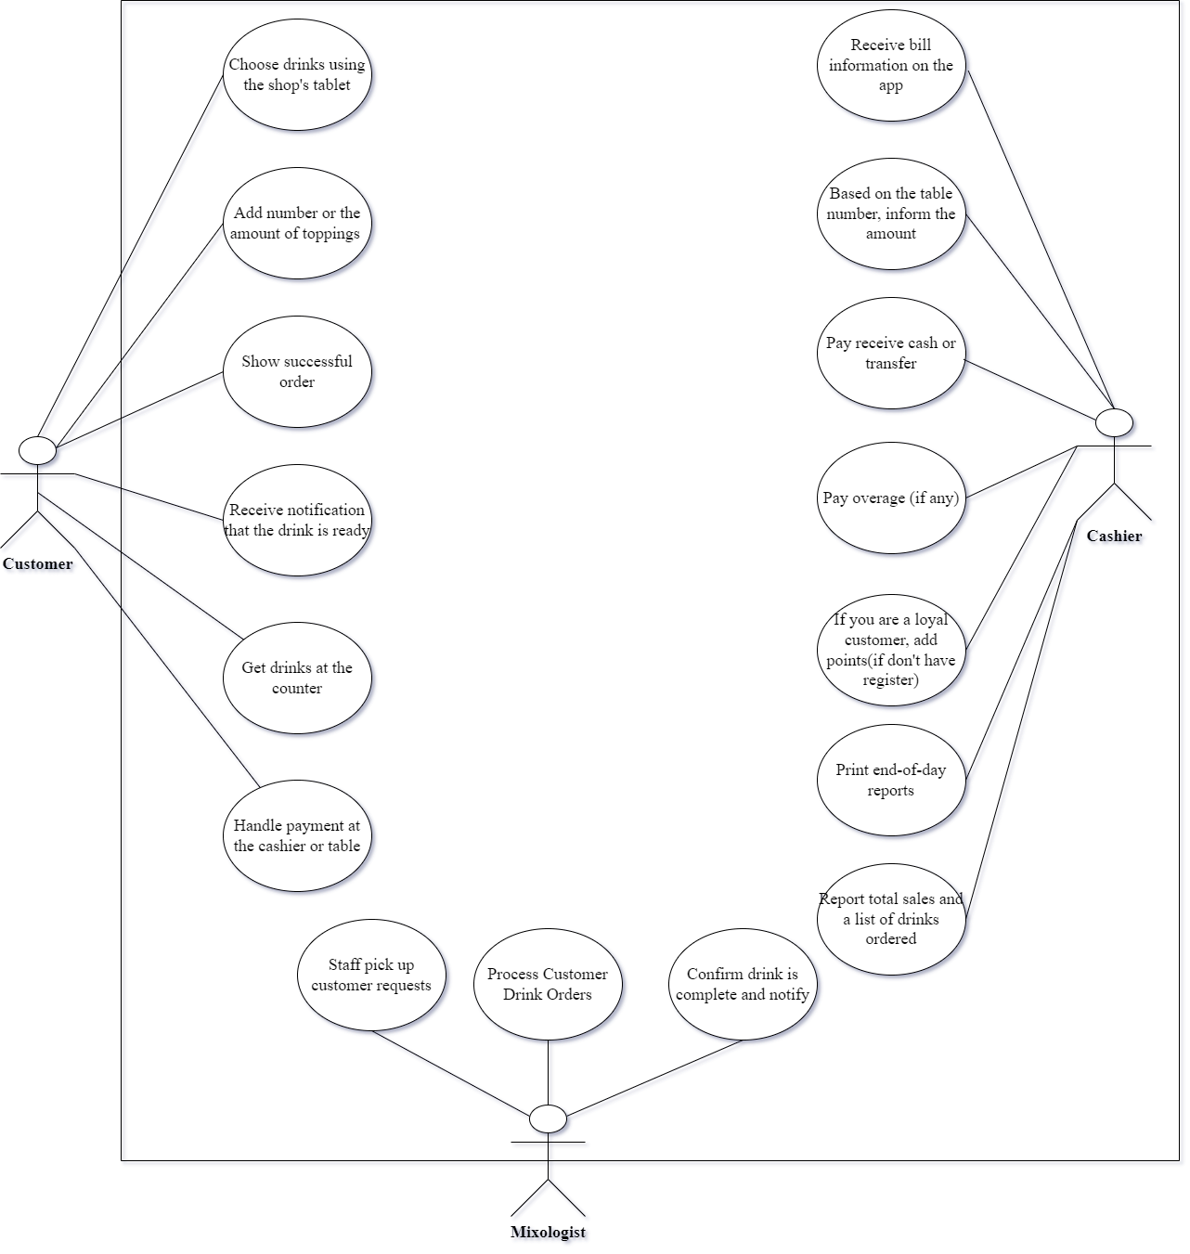

## **10.2.** **List of Business Rule**

|  |  |  |
| --- | --- | --- |
| Code | Business rules | Use case |
| *BR1* | *Customers can only view and order drinks displayed on the menu for the current day.*  *The system should update the menu daily to ensure customers have access to the latest offerings.*  *Customers can only place orders during the operating hours of the coffee shop.* | *UC.02* |
| *BR2* | *The Mixologist must confirm drink preparation on the system for each order.*  *Upon receiving an order, the Mixologist marks the drink as "in preparation" in the system.*  *Once the drink is ready, the Mixologist updates the system to indicate its prepared status.* | *UC.02* |
| *BR3* | *The cashier must announce the amount and calculate change for each customer.*  *The cashier informs the customer of the total amount due after processing the order.*  *Change is calculated accurately, and the cashier communicates it to the customer.* | *UC. 03* |
| *BR4* | *The web browser should display the current menu and daily offerings.*  *The online menu is updated in real-time to reflect any changes or additions.*  *Daily offerings include special promotions or limited-time drinks.* | *UC.04* |
| *BR5* | *The web browser should display the current menu and daily offerings.*  *The online menu is updated in real-time to reflect any changes or additions.*  *Daily offerings include special promotions or limited-time drinks.* | *UC.05* |
| *BR6* | *Bonus points are added to the customer's account when scanning their card.*  *Customers are prompted to scan their loyalty card during the payment process.*  *The system automatically adds bonus points based on the total purchase amount.* | *UC.06* |

## **10.3. Activity Diagram**

### **a) The steps performed of function abc….**

|  |  |
| --- | --- |
| **Actor Action** | **System Response** |
| **1.Place an Order** | **1.** **Save the order, notify when drinks are ready, update the bill** |
| **2.** **Drink Preparation** | **2.** **Update the status of prepared drinks** |
| **3.** **Cashier Transaction** | **3.** **Update sales record, calculate change, print end-of-day report** |
| **4.** **Web Browsing** | **4.** **Display current menu, show daily offerings** |
| **5.** **Card Scanning or cash** | **5.** **Process payment, add bonus points to the customer's account** |

### **b) Activity Diagram of function abc….**

# **11. INTERFACE DESIGN**

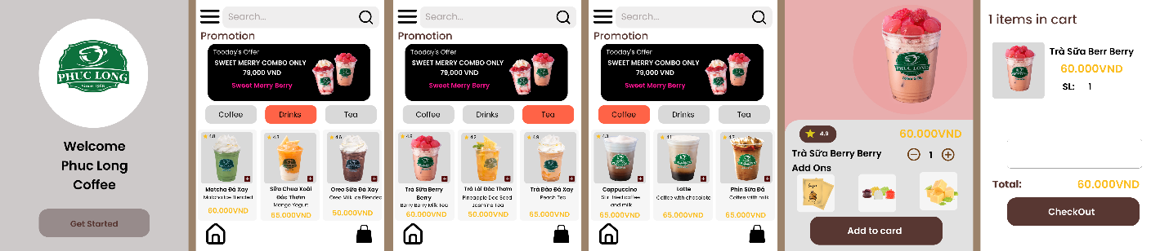

## **11.1. Introduction tool design**

Figma is a cloud-based design and prototyping tool that allows collaborative design and development. It is widely used for creating user interfaces, designing interactive prototypes, and facilitating team collaboration throughout the design process. Figma's key features include real-time collaboration, version history, and the ability to design and prototype within the same platform.

Canvas: The main working area where you create your designs.

Layers Panel: Manage and organize layers within your design.

Properties Panel: Adjust properties of selected elements.

Assets Panel: Store and reuse design components.

Creating Designs:

Use shapes, text, and drawing tools to create visual elements.

Import images and icons to enhance your design.

Utilize Figma's design constraints for responsive layouts.

## **11.2 User Interface Design for ABC Function**

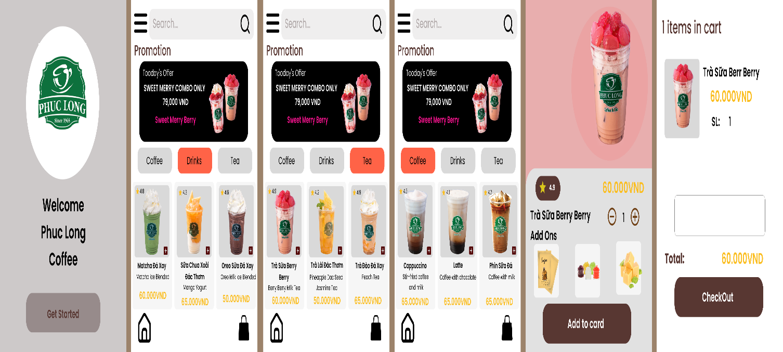

# **12. CONFIGURATION MANAGEMENT**

### **a) Introduction the tool Source Code Management**

**<** Tìm hiều và Giới thiệu công cụ quản lý mã nguồn (Git Hub).**>**

### **b) Introduction Key Functional**

*<Các chức năng chính ở công cụ này.>*

### **c) The Screen Shot apply Source Code Management of team**

<Giao diện quản lý mã nguồn/tài liệu của nhóm>

# **13. TESTING**

### **a) Introduction to method testing apply of this project**

*<Giới thiệu phương pháp kiểm thử được áp dụng cho dự án>*

### **b) Test Cases**

*<Thiết kế test case cho các chức năng (05 chức năng bất kỳ), theo mẫu Test Case đính kèm>*

# **14. CONTRIBUTION**

*<Team member contributed significantly to team's success (%)>*

|  |  |  |  |  |
| --- | --- | --- | --- | --- |
| **No.** | **Participant**  *<Họ tên>* | **Role**  *<Vai trò>* | **Responsibilities**  *<Trách nhiệm cụ thể được phân công, đóng góp cho bài tập nhóm>* | **%**  *Mức độ (%) đóng góp cho bài tập nhóm* |
| **1** | **Nguyễn Đình Tuấn** | **TeamLeader** | **Làm mục 9 10.3 11 12** |  |
| **2** | **Lê Hữu Quyền** | **Teammember** | **7.1-7.2** |  |
| **3** | **Nguyễn Đình Phi** | **Teammember** | **10.1-10.2** |  |
| **4** | **Thân Quang Huy** | **Teammember** | **6.3 a,b** |  |
| **5** | **Trần Nguyễn Hữu Trọng** | **Teammember** | **7.3-7.4** |  |